**Supplementary material for the paper “The uneven state-distribution of homicides in Brazil and their effect on life expectancy, 2000-15”**

**Authors:**

José Manuel Aburto, Ph.D.a,b

Júlia Calazans, Ph.D.c

Bernardo L. Queiroz, Ph.D.c

Shammi Luhar, Ph.D.d

Vladimir Canudas-Romo, Ph.D.e

**Author affiliations:**

a Interdisciplinary Center on Population Dynamics, University of Southern Denmark.

b Max Planck Institute for Demographic Research, Rostock, Ger-many.

c CEDEPLAR, Universidade Federal de Minas Gerais, Belo Horizonte, Brazil.

d University of Cambridge.

e School of Demography, Australian National University.

**Corresponding author:**

José Manuel Aburto

Email: jmaburto@sdu.dk

Tel. number: +45 65 50 94 16

Address: J.B. Winsløws Vej 9. DK-5000 Odense C, Denmark.

**Section 1. Death Distribution Methods summary**

The first step of the study is to assess the quality and adjust the mortality data from states in Brazil. This analysis is done using a series of traditional demographic methods, better known as Death Distribution Methods (Hill, You and Choi, 2009). These methods were developed, based on population dynamics equations, to assess the coverage of deaths in relation to the population and the quality of the declaration of information on deaths and population. The methods compare the distribution of deaths by age with the age distribution of the population and provide the age pattern of mortality for a defined period (Murray, et.al, 2010; Hill, You and Choi, 2009). There are three main methods of evaluating the quality of mortality data: general growth balance (GGB), synthetic extinct generation (SEG) and the adjusted synthetic extinct generations (SEG-adj ). The methods have very strong assumptions: population is closed to migration or subject to very small migration flows, the degree of coverage of deaths is constant by age, the degree of coverage of the population counts is constant by age, and the ages of the living and of deaths are declared without errors.

GGB is derived from the basic demographic equilibrium equation, which defines the rate of population growth as the difference between the rate of entry and the rate of exit of the population. This relationship, according to Hill (1987), also occurs for any age segment with open interval x +, and the entries occur as birthdays at ages x. Thus, the difference between the entry rate x + and the population growth rate x + produces a residual estimate of the mortality rate x + (Hill, 1987; Hill, You and Choi, 2009). If the residual mortality estimate can be estimated from two population censuses, and compared with a direct mortality estimate using the death registry, the degree of coverage of the death registry can be estimated and mortality data adjusted (Hill, 1987; Hill, You and Choi, 2009; Murray, et.al, 2010).

SEG uses age-specific growth rates to convert an age distribution of deaths into an age distribution of a population. In a stationary population the deaths observed after a certain age x are equal to the population over the same age x, we have that the deaths of a population over age x provide an estimate of the population over the same age. Age-specific population growth rates are used to adjust the number of deaths in the stationary population for an unstable population. The sum of the number of deaths over age x gives an estimate of the population over age x. The degree of coverage of the death record will be given by the ratio between the deaths estimated by the population above age x and the population observed above age x.

Hill, You and Choi (2009) suggest a combination of the methods of GGB and SEG that can be more robust than the application of the two methods separately. The adjusted method consists of applying the GGB to obtain estimates of the change in census coverage , and using that estimate to adjust one of the demographic censuses (population enumeration) and then apply SEG method with the adjusted population to obtain the degree of coverage of the mortality data.

Although they have some limitations, DDMs provide very robust and consistent results for a series of applications across the globe. For instance, [Peralta et al., 2019](http://www.scielo.br/scielo.php?pid=S0102-30982019000100168&script=sci_arttext&tlng=pt#B21) applied the methods to evaluate data quality at the sub-national level in Ecuador. Glei, Barbieri and Santamaria-Ulloa (2019) studied the quality of mortality estimates in Costa Rica and compared to other estimates. [Wang](http://www.scielo.br/scielo.php?pid=S0102-30982019000100168&script=sci_arttext&tlng=pt#B32) et al. (2016) shows the application of DDM as part of the procedures of the Global Burden of Diseases and  [Lima and Queiroz (2014](http://www.scielo.br/scielo.php?pid=S0102-30982019000100168&script=sci_arttext&tlng=pt#B18)) evaluate quality of mortality information for small-areas in Brazil overtime.

References

Bennett, N. G., & Horiuchi, S. (1981). Estimating the completeness of death registration in a closed population. *Population index*, 207-221.

Bennett, N. G., & Horiuchi, S. (1984). Mortality estimation from registered deaths in less developed countries. *Demography*, *21*(2), 217-233.

Glei, D. A., Barbieri, M., & Santamaría-Ulloa, C. (2019). Costa Rican mortality 1950-2013: An evaluation of data quality and trends compared with other countries. *Demographic research*, *40*, 835.

Hill, K. (1987, May). Estimating census and death registration completeness. In *Asian and Pacific population forum/East-West Population Institute, East-West Center* (Vol. 1, No. 3, pp. 8-13). The Asian & Pacific Population Forum.

Hill, K., You, D., & Choi, Y. (2009). Death distribution methods for estimating adult mortality: sensitivity analysis with simulated data errors. *Demographic Research*, *21*, 235-254.

Lima, E. E. C. D.; Queiroz, B. L. Evolution of the deaths registry system in Brazil: associations with changes in the mortality profile, under-registration of death counts, and ill-defined causes of death. Cadernos de Saúde Pública, v. 30, n. 8, p. 1721-1730, 2014.

Murray, C. J., Rajaratnam, J. K., Marcus, J., Laakso, T., & Lopez, A. D. (2010). What can we conclude from death registration? Improved methods for evaluating completeness. *PLoS medicine*, *7*(4).

Peralta, A., Benach, J., Borrell, C., Espinel-Flores, V., Cash-Gibson, L., Queiroz, B. L., & Marí-Dell’Olmo, M. (2019). Evaluation of the mortality registry in Ecuador (2001–2013)–social and geographical inequalities in completeness and quality. *Population health metrics*, *17*(1), 3.

WANG, H. et al. Global, regional, and national life expectancy, all-cause mortality, and cause-specific mortality for 249 causes of death, 1980-2015: a systematic analysis for the global burden of disease study 2015. Lancet. n. 388, p. 1459-544, 2016.

**Section 2. Decomposition method summary**

The decomposition method used in this paper is based on the line integral model (Horiuchi et al 2008). Suppose $f$ (e.g. $e^{†}$ or life expectancy) is a differentiable function of $n$ covariates (e.g. each age-cause specific mortality rate) denoted by the vector $A=[x_{1},x_{2}, …,x_{n}]^{T}$. Assume that $f$ and $A$ depend on the underlying dimension $t$, which is time in this case, and that we have observations available in two time points $t_{1}$ and $t_{2}$. Assuming that $A$ is a differentiable function of $t$ between $t_{1}$ and $t_{2}$, the difference in $f$ between $t_{1}$ and $t_{2}$ can be expressed as follows:

$$f_{2}-f_{1}= \sum_{i=1}^{n}{\int_{x_{i}\left(t_{1}\right)}^{x_{i}\left(t_{2}\right)}{\frac{∂f}{∂x_{i}}dx_{i}=\sum_{i=1}^{n}{c_{i}}}}, (2)$$

where $c_{i}$ is the total change in $f$ (e.g. $e^{†}$ or life expectancy) produced by changes in the $i$-th covariate, $x_{i}$. The $c_{i}$'s in equation (2) were computed with numerical integration following the algorithm suggested by Horiuchi et al (2008). This method has the advantage of assuming that covariates change gradually along the time dimension

**Figure S1. Map of states in Brazil.**

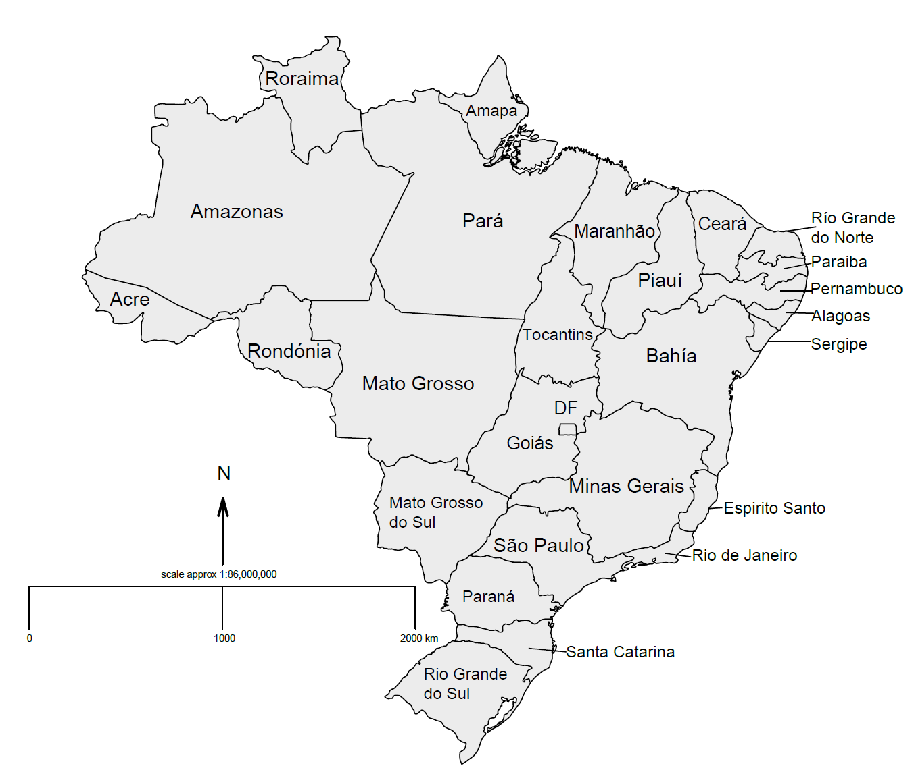

**Figure S2. Cause specific contributions to changes in male life expectancy by state in Brazil.**

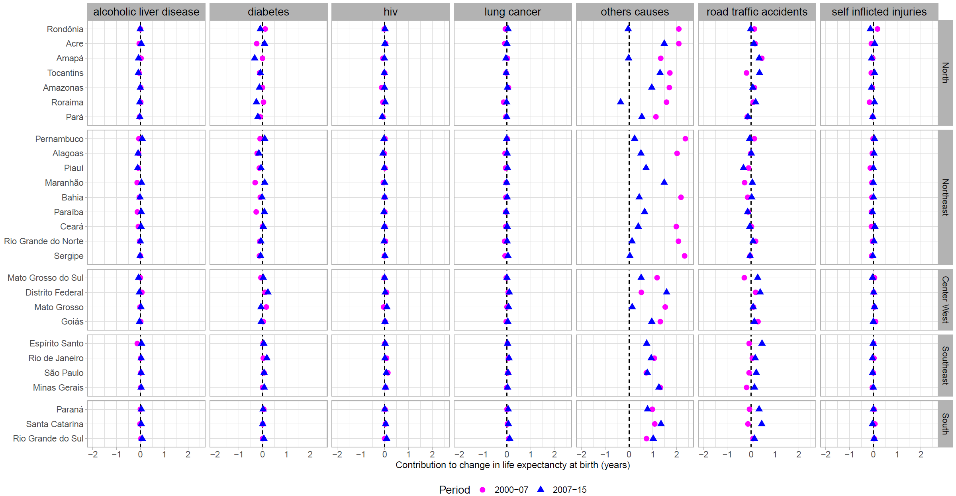

**Figure S3. Cause specific contributions to changes in female life expectancy by state in Brazil.**

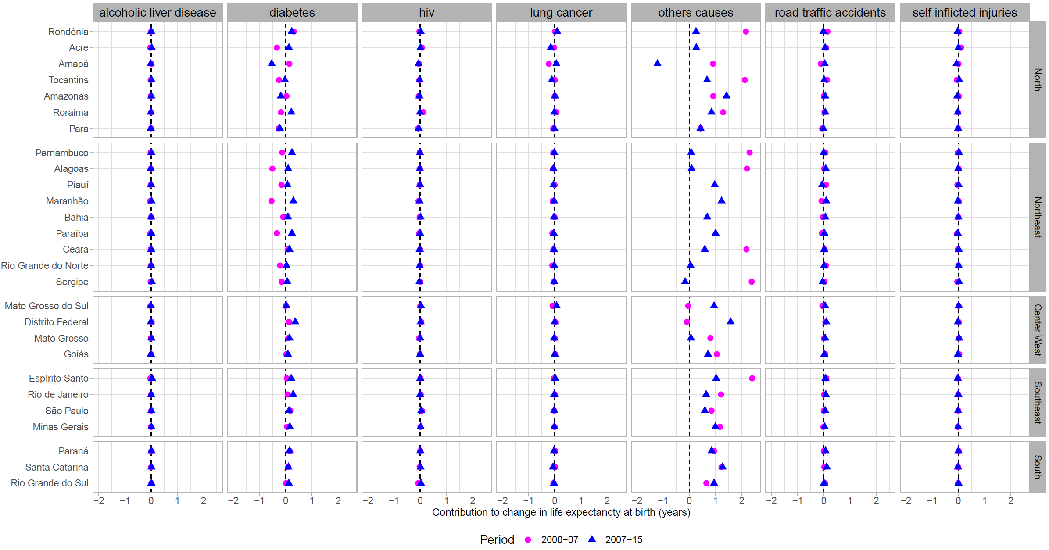

**Figure S4. Homicide contributions to changes in male life expectancy by state in Brazil in 2007-15.**

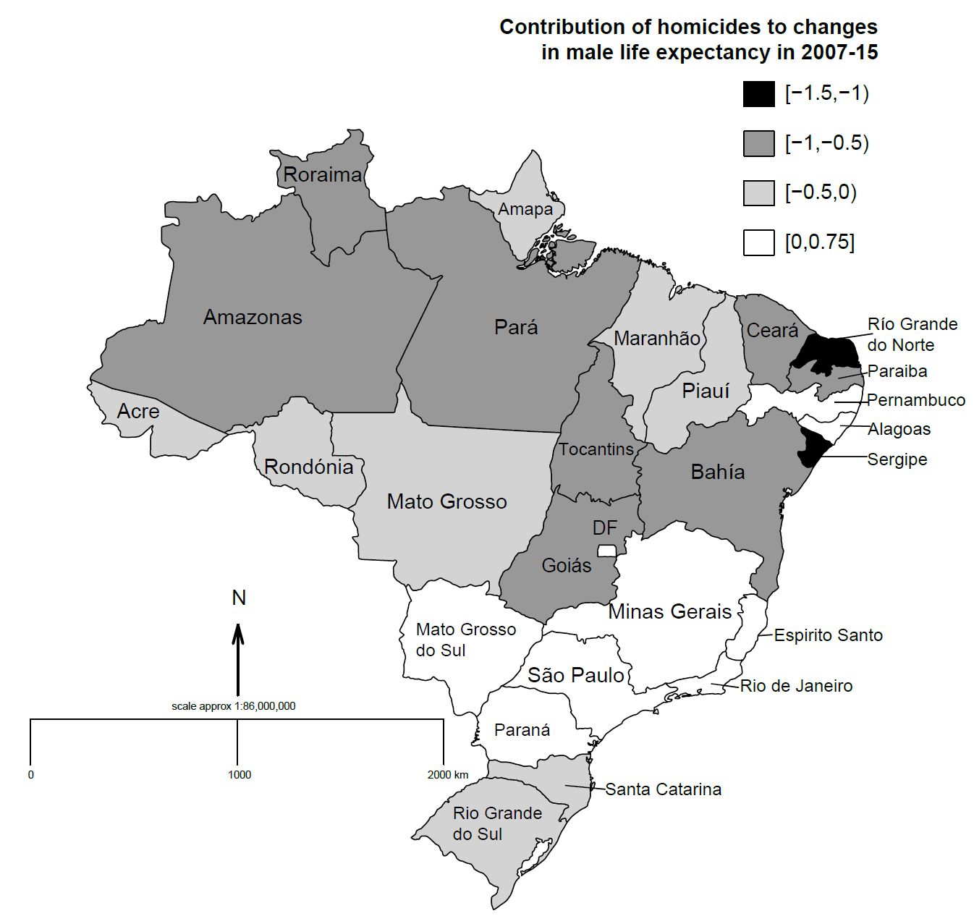

**Appendix Table 1**

|  |  |  |
| --- | --- | --- |
| Cause | code | descrition |
| Homicide | X85 | Assault by drugs, medicaments, and biological substances |
| X86 | Assault by corrosive substance |
| X87 | Assault by pesticides |
| X88 | Assault by gases and vapors |
| X89 | Assault by other specified chemicals and noxious substances |
| X90 | Assault by unspecified chemical or noxious substance |
| X91 | Assault by hanging, strangulation, and suffocation |
| X92 | Assault by drowning and submersion |
| X93 | Assault by handgun discharge |
| X94 | Assault by rifle, shotgun, and larger firearm discharge |
| X95 | Assault by other and unspecified firearm discharge |
| X96 | Assault by explosive material |
| X97 | Assault by smoke, fire, and flames |
| X98 | Assault by steam, hot vapors, and hot objects |
| X99 | Assault by sharp object |
| Y00 | Assault by blunt object |
| Y01 | Assault by pushing from high place |
| Y02 | Assault by pushing or placing victim before moving object |
| Y03 | Assault by crashing of motor vehicle |
| Y04 | Assault by bodily force |
| Y05 | Sexual assault by bodily force |
| Y06 | Neglect and abandonment |
| Y07 | Other maltreatment syndromes |
| Y08 | Assault by other specified means |
| Y09 | Assault by unspecified means |
| Suicide and self-inflicted injuries | X60 | Intentional self-poisoning by and exposure to nonopioid analgesics, antipyretics, and antirheumatics |
| X61 | Intentional self-poisoning by and exposure to antiepileptic, sedative-hypnotic, antiparkinsonism, and psychotropic drugs, not elsewhere classified |
| X62 | Intentional self-poisoning by and exposure to narcotics and psychodysleptics [hallucinogens], not elsewhere classified |
| X63 | Intentional self-poisoning by and exposure to other drugs acting on the autonomic nervous system |
| X64 | Intentional self-poisoning by and exposure to other and unspecified drugs, medicaments, and biological substances |
| X65 | Intentional self-poisoning by and exposure to alcohol |
| X66 | Intentional self-poisoning by and exposure to organic solvents and halogenated hydrocarbons and their vapors |
| X67 | Intentional self-poisoning by and exposure to other gases and vapors |
| X68 | Intentional self-poisoning by and exposure to pesticides |
| X69 | Intentional self-poisoning by and exposure to other and unspecified chemicals and noxious substances |
| X70 | Intentional self harm by hanging, strangulation, and suffocation |
| X71 | Intentional self harm by drowning and submersion |
| X72 | Intentional self harm by handgun discharge |
| X73 | Intentional self harm by rifle, shotgun, and larger firearm discharge |
| X74 | Intentional self harm by other and unspecified firearm discharge |
| X75 | Intentional self harm by explosive material |
| X76 | Intentional self harm by smoke, fire, and flames |
| X77 | Intentional self harm by steam, hot vapors, and hot objects |
| X78 | Intentional self harm by sharp object |
| X79 | Intentional self harm by blunt object |
| X80 | Intentional self harm by jumping from a high place |
| X81 | Intentional self harm by jumping or lying before moving object |
| X82 | Intentional self harm by crashing of motor vehicle |
| X83 | Intentional self harm by other specified means |
| X84 | Intentional self harm by unspecified means |
| HIV/AIDS | B20 | Human immunodeficiency virus [HIV] disease resulting in infectious and parasitic diseases |
| B21 | Human immunodeficiency virus [HIV] disease resulting in malignant neoplasms |
| B22 | Human immunodeficiency virus [HIV] disease resulting in other specified diseases |
| B23 | Human immunodeficiency virus [HIV] disease resulting in other conditions |
| B24 | Unspecified human immunodeficiency virus [HIV] disease |
| Ischemic heart diseases | I20 | Angina pectoris |
| I21 | Acute myocardial infarction |
| I22 | Subsequent ST elevation (STEMI) and non-ST elevation (NSTEMI) myocardial infarction |
| I23 | Certain current complications following ST elevation (STEMI) and non-ST elevation (NSTEMI) myocardial infarction |
| I24 | Other acute ischemic heart diseases |
| I25 | Chronic ischemic heart disease |
| Lung cancer | C34 | Malignant neoplasm of bronchus and lung |
| Diabetes | E10 | Insulin-dependent diabetes mellitus |
| E11 | Noninsulin-dependent diabetes mellitus |
| E12 | Malnutrition-related diabetes mellitus |
| E13 | Other specified diabetes mellitus |
| E14 | Unspecified diabetes mellitus |
| Road traffic acidentes | V00-V09 | Pedestrian injured in transport accident |
| V10-V19 | Pedal cycle rider injured in transport accident |
| V20-V29 | Motorcycle rider injured in transport accident |
| V30-V39 | Occupant of three-wheeled motor vehicle injured in transport accident |
| V40-V49 | Car occupant injured in transport accident |
| V50-V59 | Occupant of pick-up truck or van injured in transport accident |
| V60-V69 | Occupant of heavy transport vehicle injured in transport accident |
| V70-V79 | Bus occupant injured in transport accident |
| V80-V89 | Other land transport accidents |
| Alcoholic liver disease | K70 | Alcoholic liver disease |
| Avoidable causes of deaths due to interventions of the Brazilian Health System |  | See Malta et al (2007) and Malta et al. (2010) |